

Welcome to Ilderton
The Ilderton Foundation is a registered charity, which has spent the last 35 years offering young people the opportunity to learn about vehicles - everything from motorbikes to go-karts and bikes.

Our aim is for young people to acquire basic skills in motor maintenance, understand the responsibilities of car ownership, and have access to leisure activities such as supervised driving.

We enjoy working with all sorts of people: some are young offenders and young people at risk, others come to our projects via their schools or through our regular school holiday events - which are open to all and take place in various venues in south east London. We have three training centres in Deptford, Lambeth and Southwark, and more are planned; along with a driving school especially for young people.
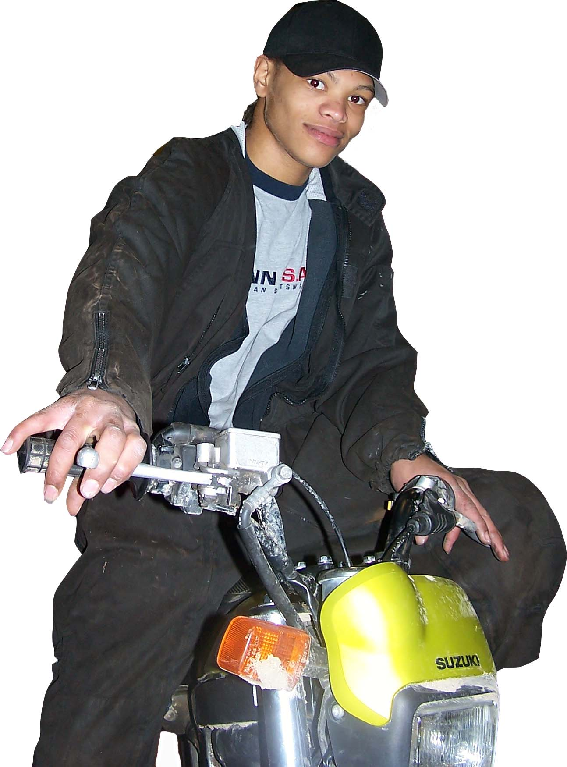
The Ilderton Foundation doesn’t only work with cars and bikes, but with anything that inspires young people: recent projects include a theatre workshop that led to a public performance. We also create outreach programmes for areas with specific needs.

Our work improves community safety by making a contribution to preventing and reducing crime. Research officers of the Inner London Probation Service concluded in a report, that offenders who attended Ilderton: “re-offended markedly less, are less likely to be sentenced to custody for re-offending and are were especially less likely to commit taking and driving away offences”

Our aims
Ilderton Foundation programmes are designed to help young people progress, wherever they start from. We aim to develop and enhance the lives of young people by providing them with training in a subject which fascinates them, re-fire their interest in learning and develop personal and teamwork skills. The result is a positive attitude towards training, education and employment.

Training goals
- To get young people interested in achieving variety of experiences and gaining qualifications
- To provide accredited pre-vocational training programmes in car maintenance, motorbike, and moped maintenance, personal development, numeracy and literacy skills
- To provide support in the transition into further education and training
- To provide advice and mentoring
- Employment
- To provide support in career planning, job search, placements, interview techniques etc

Safety
- To provide education on the principles of road safety. which includes understanding the legal aspects and requirements of car or motorbike ownership
- To introduce young people to safe driving skills
- To introduce young people to health and safety at work

Social skills
- To promote awareness of the consequences of car crime and its effect on the community and individuals
- To create a number of initiatives that will give scope for challenging existing attitudes towards offending
- To provide an area where young people can meet, encouraging teamwork, developing self-esteem and motivation

Leisure
To provide facilities for organised and constructive leisure activities, using motorised vehicles
Our programmes
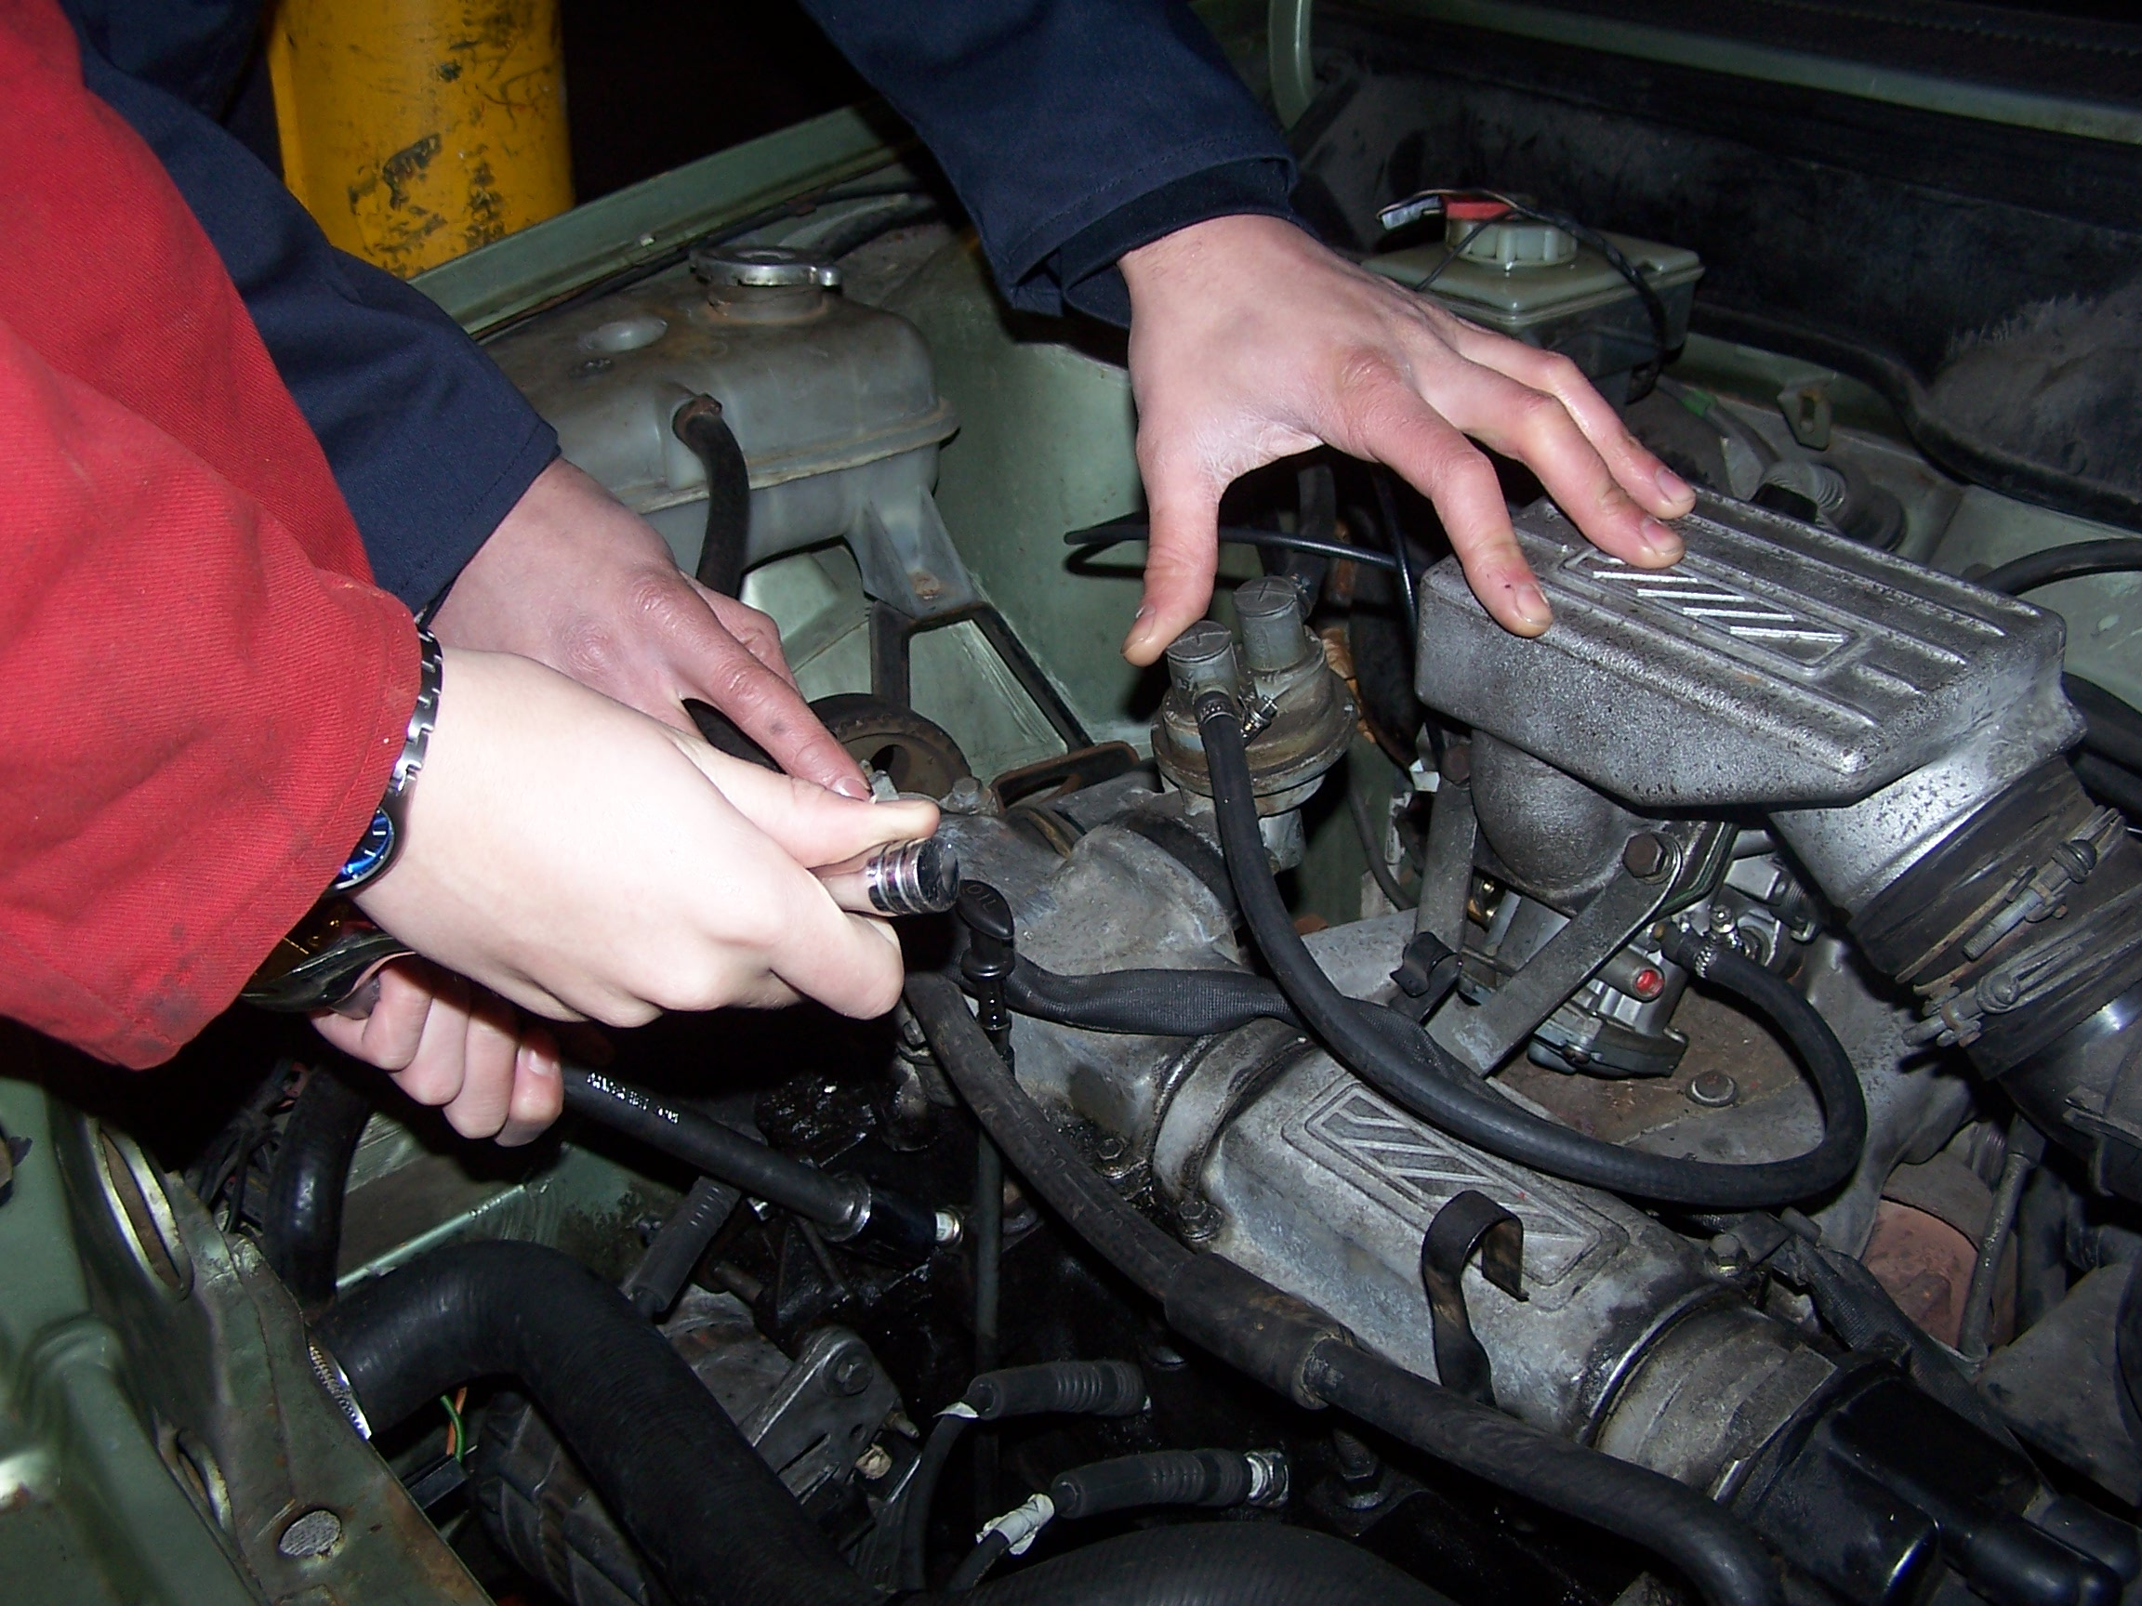

Each of our centres has a different programme of activities. Please contact each centre directly for precise dates and times.

School programmes
This programme is aimed at young people between the ages of 13-16, who are still in schools or similar institutions. It is a pre-vocational training programme in motor vehicle maintenance that offers accredited qualification through City & Guilds (City & Guilds 3791- profile of achievement & 3901-02- entry level 3- Progression to college to City and Guilds 4000 series.) and an introduction to health and safety in a work related environment. It is designed to complement the national curriculum and to enable young people to remain in mainstream education.

Basic Motor Maintenance and Personal Development Course
This programme is aimed at young people between the ages of 13-25, who are young offenders or young people at risk and not in mainstream education or training. It is a prevocational training programme in motor maintenance and personal development that offers accredited qualifications through City & Guilds. The programme also provides introduction to health and safety in a work related environment. It is designed to re-engage young people in learning and provide a recognised route into further education, training and employment.

Content
Basic motor maintenance: 10units
Personal development: communication skills, CV building, literacy and numeracy skills, life skills, and activities around challenging behaviour.

Leisure activities
Through the use of adapted cars, karts and motorbikes, we provide access to safe driving skills and responsibility in a safe controlled environment.

Motorbike programme
This 13-week programme aims to engage young people and develop a sense of responsibility in the areas of motorbike ownership and maintenance. Workshop-based practical skills and off-road riding skills are both accredited by City and Guilds.

Content
General servicing of motorbike:
Health and safety
Examination of air filter
Examination of spokes
Examination of brakes
Examination of clutch
Scrambling techniques

Reparation Training Programme
This programme is aimed at young people between the ages of 13 – 16 years, whose court orders include an aspect of reparation to a victim or the community. The training programme is designed to engage young people on short ‘taster’ programmes to enable them to meet the conditions of their court orders.

Content
Introduction to ice- breaker sessions.
Introduction to basic design and environmental issues.
Introduction to painting, use of colour and tools.
Introduction to basic construction skills.
The above includes the collection of materials e.g. tyres, which can be recycled for the benefit of the local community.

Flexible Evening Programme
The programme is aimed at young people between the ages of 13 – 25 years. The evening programmes involve basic motor maintenance and the construction of motorised vehicles for races. Along with a special programme for young women. The programmes are customised around cars, karts, and motorbikes to the needs of young people and/or the requirement of the courts.

Content
Basic motor maintenance using cars, karts, and motorbikes.
Team building activities.
Construction of cars for organised racing actives.
Health and Safety.
Youth Forum meetings.
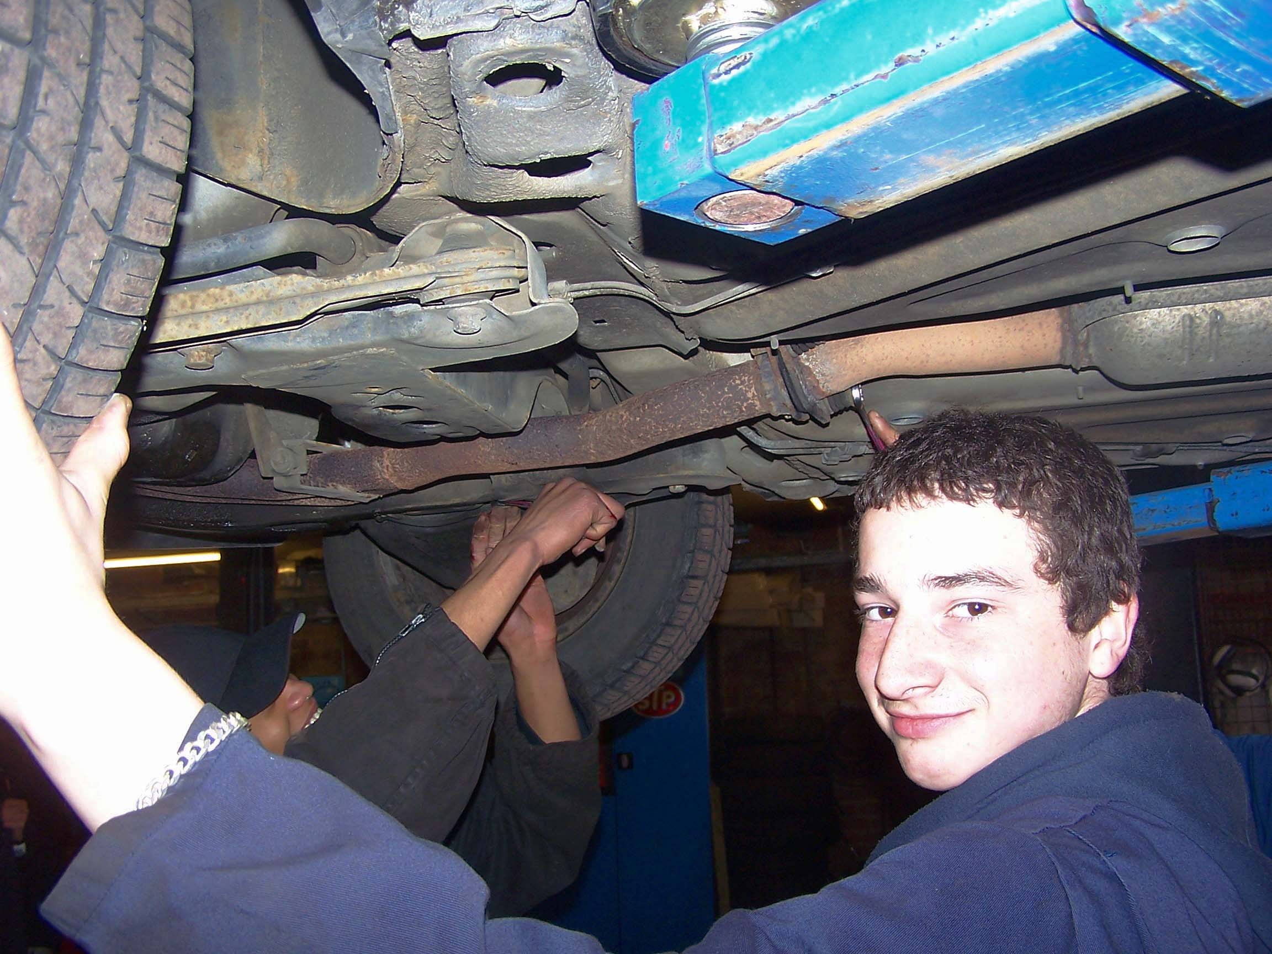

Our Partners
The Ilderton Foundation serves the London boroughs of Lewisham, Lambeth, Southwark, Bromley and Greenwich. Referral agencies include the Youth Offending Teams of Lewisham, Southwark, Bromley, Lambeth and Greenwich, along with the National Probation Service and schools throughout London. We have received funding from the National Lottery and individual donors.

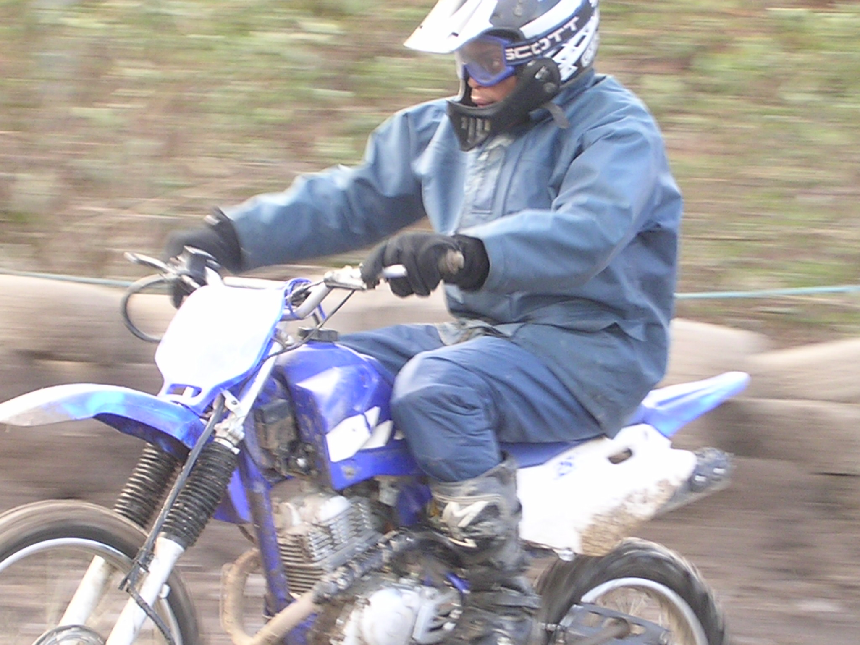
Contact us
Head and administrative office
Unit 9a, Evelyn Court
Grinstead Road
London SE8 5AD
Tel: 020 8469 0396

Deptford Training Centre
80a Edward Street
Deptford
London SE8 5HB
Tel: 020 8691 7643

Southwark Training Centre
Temporarily at the above address

Lambeth Training Centre
15-17 Clyston Street
London SW8 4TT
Tel: 0207 720 2383

Charity registration: 286639
Registered Company: 1685665
INVESTOR IN PEOPLE

